**Sign Up Now!**

**Class Schedule:**

9-9:30 am Check-in & Refreshments

9:30-6 pm Training

12:30 – 1:30 pm: Working lunch on site

**Date:**

**Friday, August 21 2015**

**Location:**

Mariners Landing Resort Community & Conference Center

1217 Graves Harbor Trail

Huddleston, Va. 24104

**Class cost:**

* $185/person
* Cancellation fee of $75.00

**Instructor:**

**Denise Scruggs, ADC, CDP & CADDCT**

Denise, Director of the Beard Center on Aging, is a Certified Alzheimer’s Disease & Dementia Care Trainer for the National Council of Certified Dementia Practitioners/ International Council of Certified Dementia Practitioners. She has over 20 years of experience working personally & professionally with persons diagnosed with dementia. She is a certified activity director with experience in long term care activities, memory care management, adult day care services, & consulting with families and facilities caring for those with dementia.

**Alzheimer’s Disease & Dementia Care Seminar**

**Smith Mountain Lake, Va.**

**Whether you want to increase your knowledge or**

**pursue certification as a Certified Dementia**

**Practitioner (CDP) this class is for you.**

If you are interested in becoming a CDP, this class

meets  **ONE** of the requirements for becoming a Certified Dementia Practitioner. Upon successful completion of the class, you may apply for CDP certification. For more information on certification &eligibility requirements go to [www.nccdp.org](http://www.nccdp.org) or contact the NCCDP/ICCDP Office at 1-877-729-5191 or [nccdpcorporate@nccdp.org](mailto:nccdpcorporate@nccdp.org).

You must be certified or licensed in a health care profession or related field to apply for CDP certification.

**Who should attend:** Nurses, CNA’s, Social Workers,

Activity Professionals, Geriatric Care Managers,

Licensed Nursing Home & Assisted Living Administrators, & Social Workers among other front life staff & health care professionals.

**Topics include:** diagnosis & prognosis; treatment;

communication & feelings; depression; repetitive

behaviors; paranoia & hallucinations; wandering;

hoarding; aggression; catastrophic reactions, intimacy/

sexuality; personal care; pain management; nutrition;

activities; staff & family support; environment; diversity/

cultural competence; spiritual care; and end-of-life care.

----------------------------------

**For More Information:** agingstudies@vcu.edu

**To Register:**

https://training.vcu.edu/course_detail.asp?ID=14038



YO

**Sponsored by:**

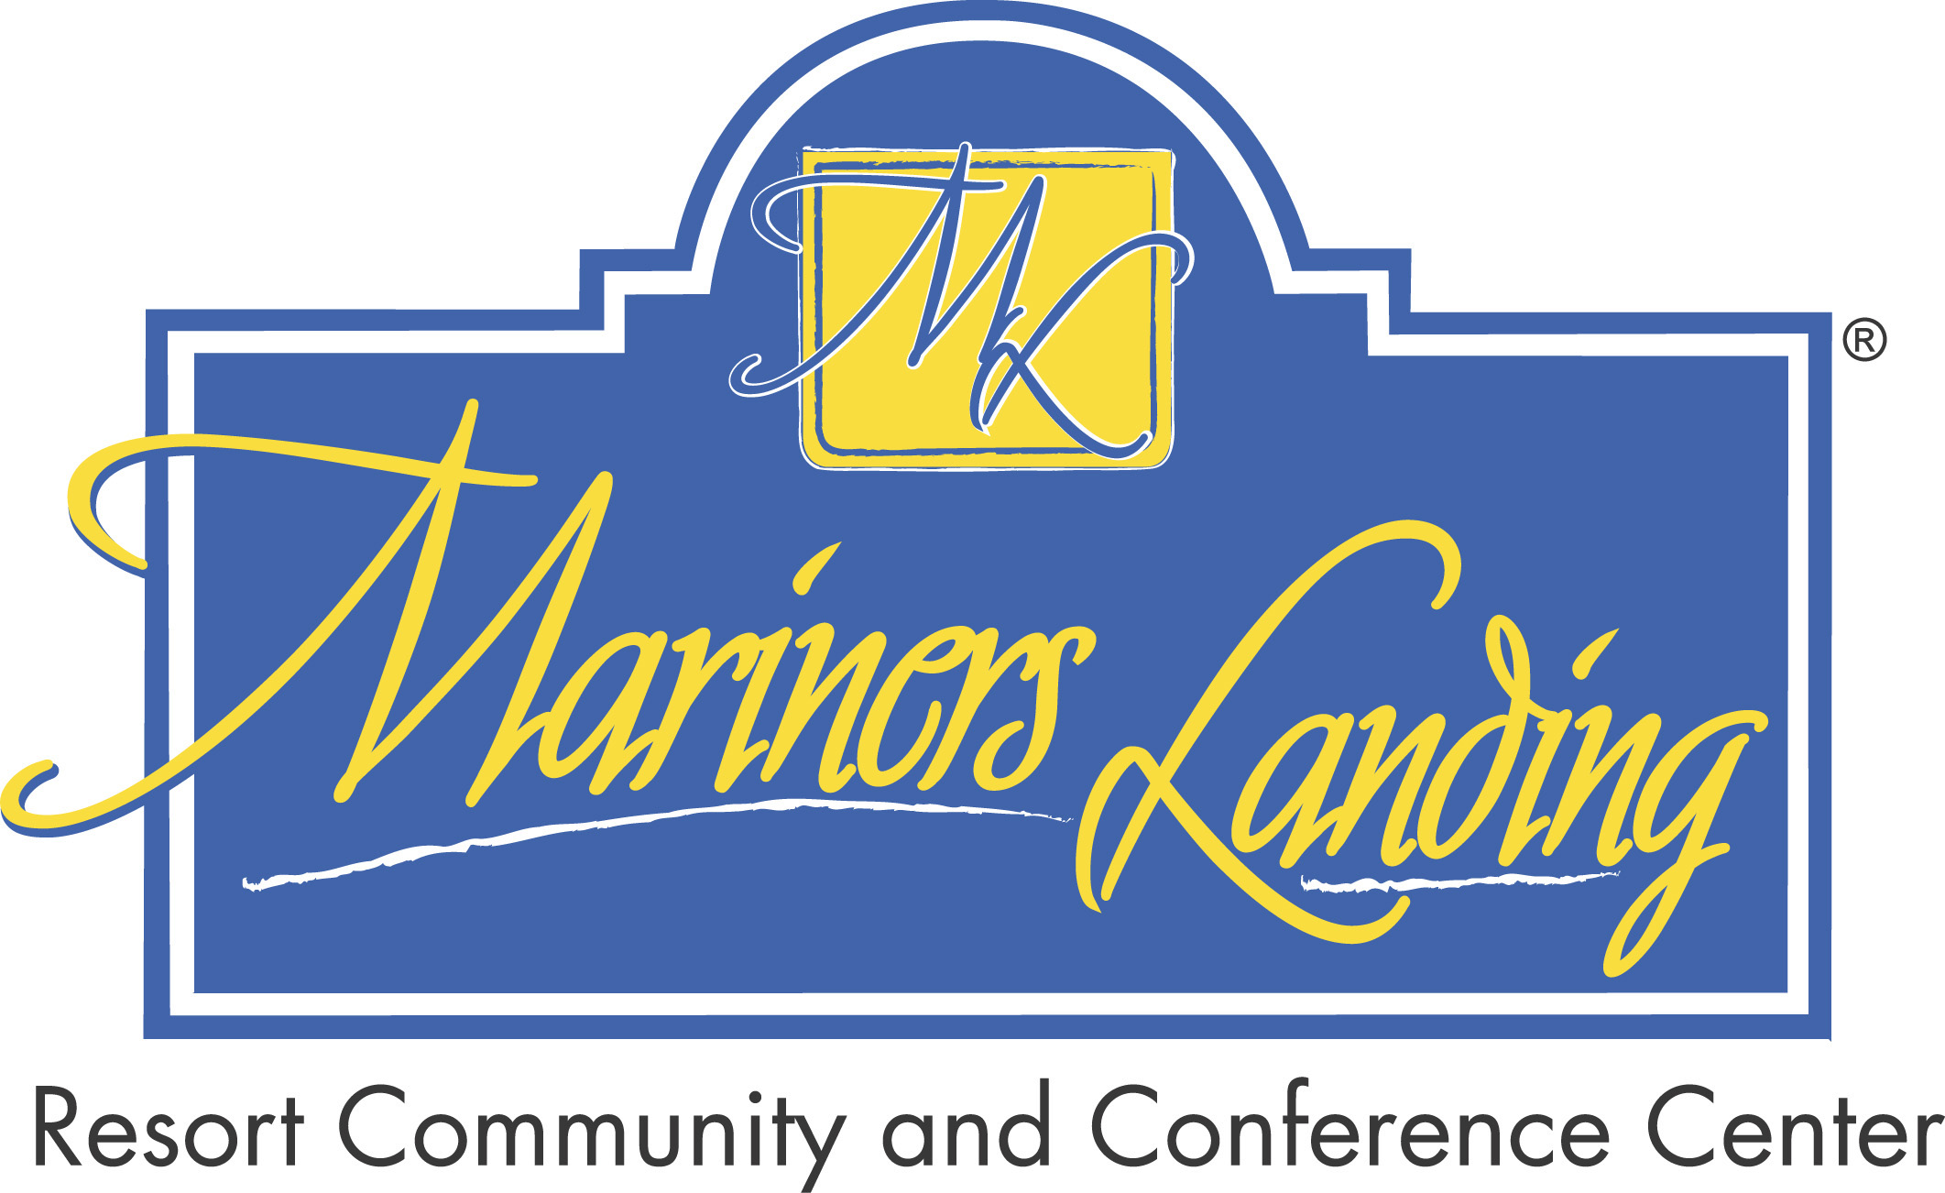

*Take the path to certification as a Certified Dementia Practitioner through the National Council of Certified Dementia Practitioners & International Council of Certified Dementia Practitioners*